REPORT FOR TASK 1, VARIANT # 8

1. First subtask:

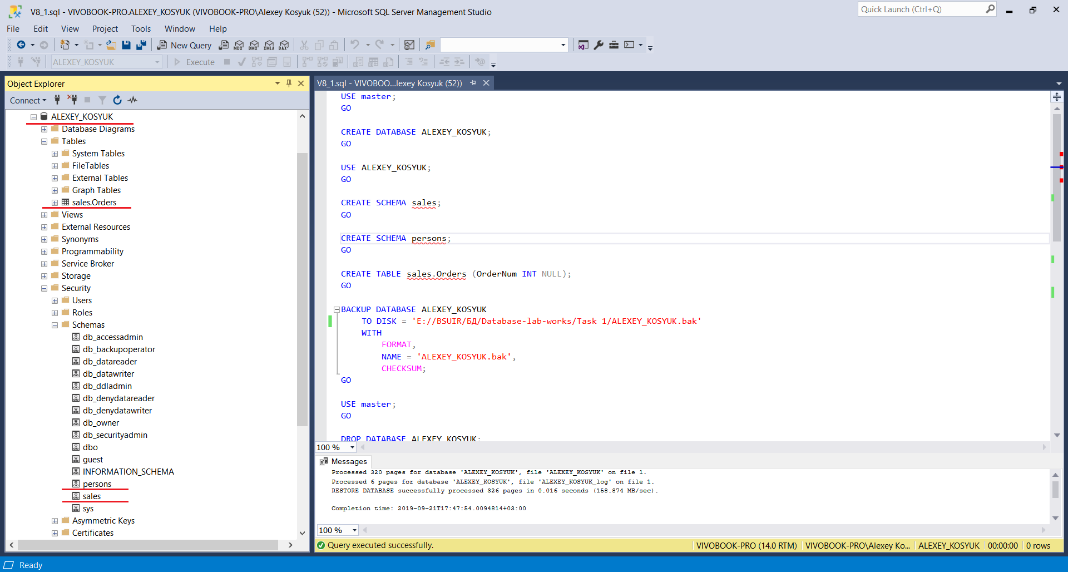

2. Second subtask:

2.1 Restore database AdventureWorks2012:

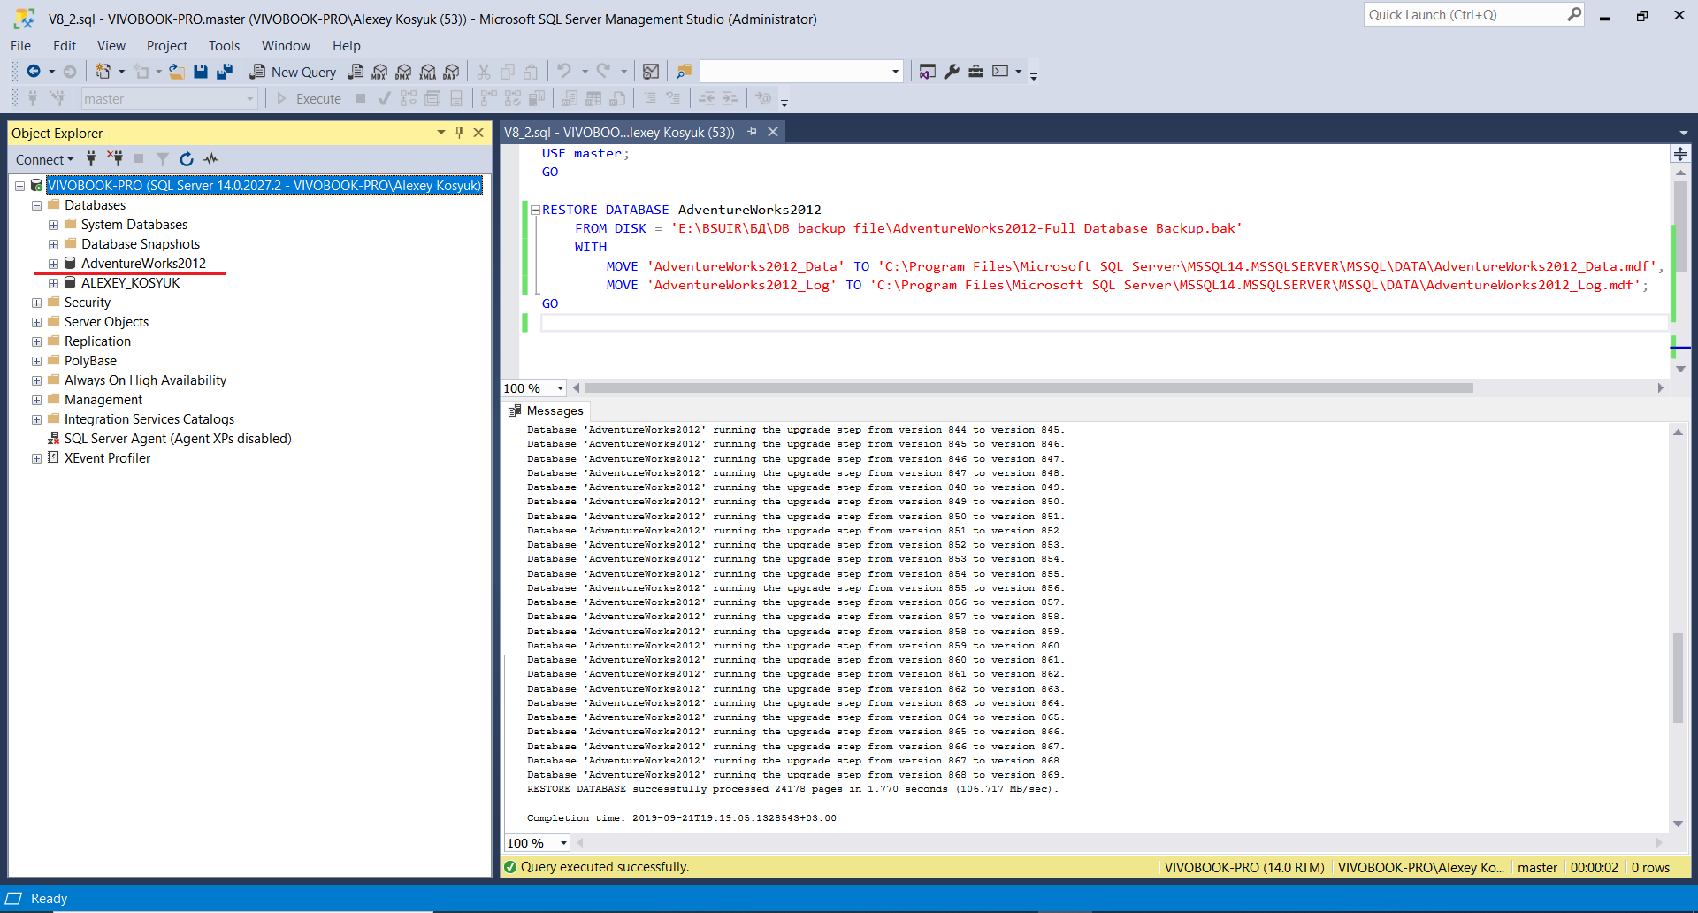

2.2 Subtask 2.1:

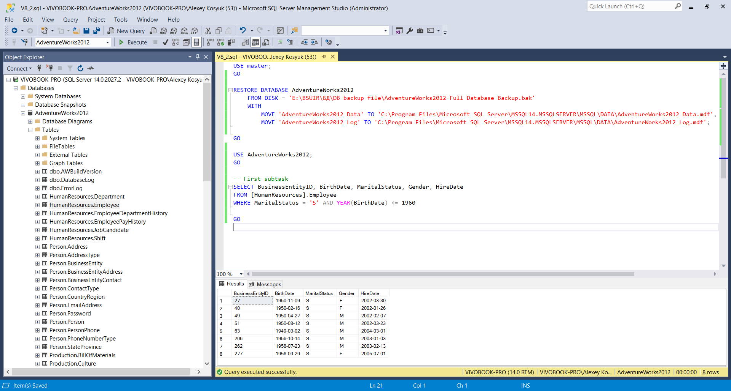

2.3 Subtask 2.2:

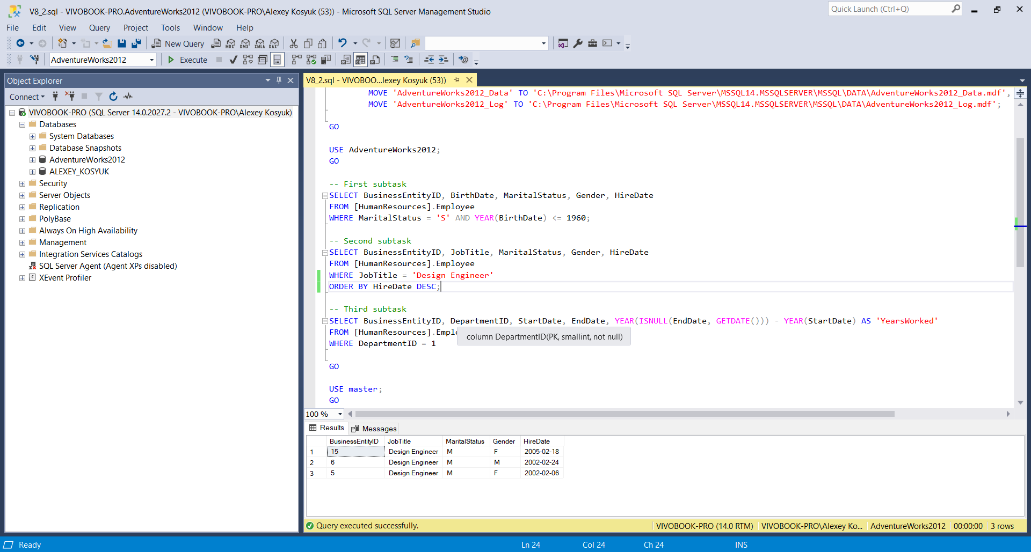

2.4 Subtask 2.3:

